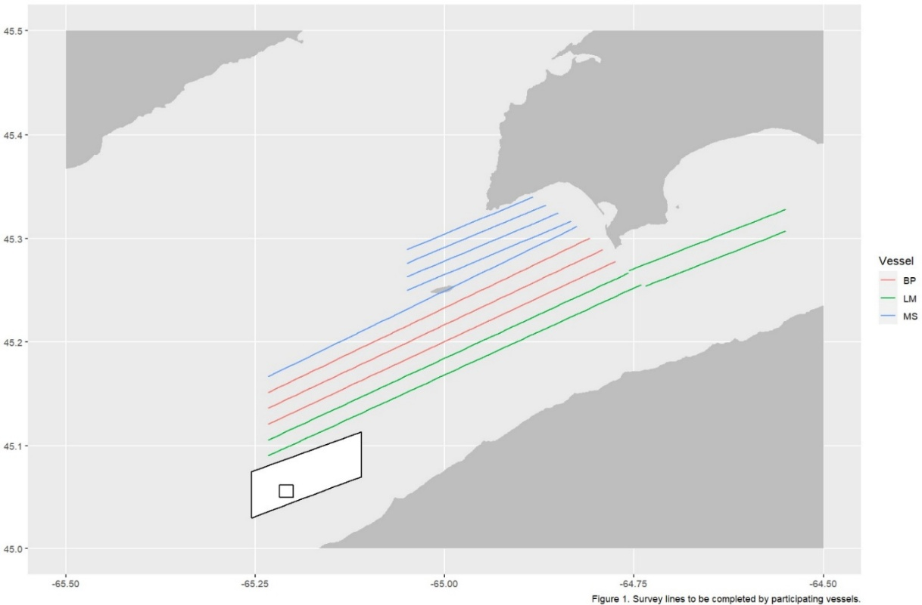
Scots Bay Survey #1 Sunday May 10, 2026

FM

This survey includes three participating vessels and begins at 19:00.
Vessel assignments are as follows: The Lady Melissa will run two lines in the Main Box and two in the Eastern Box. The Brunswick Provider will run three lines in the Main Box. Fundy Monarch will run one line in the Main Box (south of Isle Haute) and then complete the Northern Box.
Before the survey begins, the Lady Melissa will conduct plankton tows (bottom left outer box) and oceanographic sampling (bottom left inner box).
Reminder: Complete your assigned transects exactly as listed—run them straight, do not deviate, and do not fish until the survey is completed by all vessels. Deviations may result in transects being rejected and can negatively affect the overall biomass estimate. These surveys inform population trend assessments; producing the best possible estimate supports long-term fishery stability. Thank you for your participation.
If you are recording a school of fish near the end of a transect, continue recording along the same straight course, even if it carries you beyond the survey-box boundary.

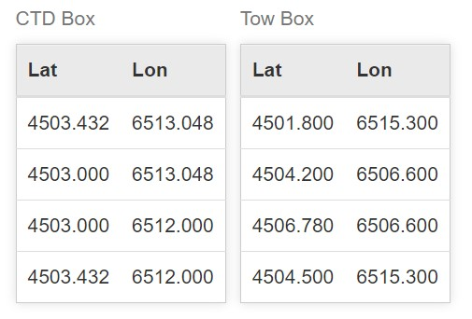

Full Lines Table
Vessel | Line No. | Start Lat | Start Lon | End Lat | End Lon
Lady Melissa | 1 | 4505.40 | 6514.00 | 4515.33 | 6444.42
Lady Melissa | 2 | 4515.24 | 6444.11 | 4518.41 | 6433.00
Lady Melissa | 3 | 4519.70 | 6433.00 | 4516.12 | 6445.43
Lady Melissa | 4 | 4516.01 | 6445.44 | 4506.32 | 6514.00
Brunswick Provider | 1 | 4507.24 | 6514.00 | 4516.68 | 6446.45
Brunswick Provider | 2 | 4517.35 | 6447.47 | 4508.16 | 6514.00
Brunswick Provider | 3 | 4509.08 | 6514.00 | 4518.03 | 6448.48
Fundy Monarch | 1 | 4510.00 | 6514.00 | 4518.70 | 6449.50
Fundy Monarch | 2 | 4519.00 | 6450.00 | 4515.00 | 6503.00
Fundy Monarch | 3 | 4515.78 | 6503.00 | 4519.47 | 6451.00
Fundy Monarch | 4 | 4519.93 | 6452.00 | 4516.57 | 6503.00
Fundy Monarch | 5 | 4517.35 | 6503.00 | 4520.40 | 6453.00

Instructions
- Plan to arrive at the starting point 30 minutes before the start time of 19:00.
- Start the EK80 software and load your 2026 Herring Survey settings. When you are ready to begin, Record Raw should be turned ‘ON’ and the ‘REC’ dot in the upper left should turn from black to red. Check that the lat and long in the top center of the screen is changing.
- Commence surveying first line at 19:00 and maintain a speed at 8 knots.
- Run your lines straight and double check that the recorder is turned on and red.
- Maintain log sheets as a backup to recorders every 15 minutes.
- Make sure to record time and GPS coordinates for the start and end of each line.
- This is a fishing survey with an allowance of 125 mt/vessel.

Tidal Chart – Margaretsville, NS
2026-05-10 (Sun)
Time ADT | Height (m) | Height (ft)
0:18 | 2.252 | 7.4
6:23 | 8.836 | 29
12:42 | 1.903 | 6.2
18:55 | 8.77 | 28.8
2026-05-11 (Mon)
Time ADT | Height (m) | Height (ft)
1:07 | 2.046 | 6.7

